Exhibition Application Form

Please fill out the below application form, and send it back to the secretariat (icmovpe2026@icmovpe2026.org)
▌Company Information
Company Name
President / CEO
Website
Address
City / Country |  | Postal Code
Telephone |  | Mobile
E-mail |  | Fax
Contact Person Name
Job Title |  | Department

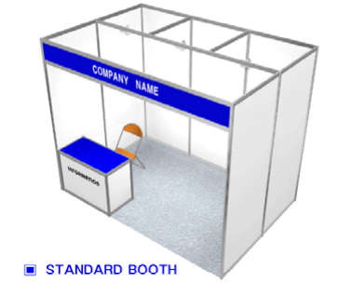
▌Exhibition Opportunity

Category | Fee
Prefabricated Booth | 3,000,000 KRW (1EA)
※ Benefits for Exhibitors (Per One Booth)
- 2 Free Registration (included lunch ticket and Conference Kit)
- Logo and Web link on the Website
- Logo on the Program Book

▌Exhibition Application
Category | Quantity | Total Amount
Prefabricated Booth  (1 EA = 3,000,000 KRW) | Booth(s) | KRW
▌Account Information
Account Holder | 사단법인 한국광전자공학회 조용훈
Account Number | 100-035-605475
Bank Name | Shinhan Bank
SWIFT BIC | SHBKKRSE
Bank Address | Shinhan Bank Donam-dong Branch, 89 Dongsomun-ro, Seongbuk-gu, Seoul, Republic of Korea

Name of Applicant: _______________ Date : _____________________

Signature: _________________

